The goal for your presenting is to blow up your credibility + trust
The biggest creators in the world are still trying to improve their presenting, it’s the foundation of our entire video and something we should always look to improve.
The two types of presenters
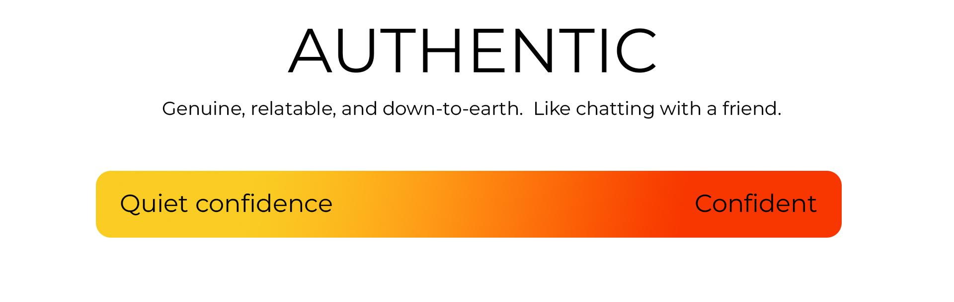
Genuine and Relatable: Presents content in a way that feels sincere, sharing personal stories and insights that resonate on a personal level with viewers.
Conversational Tone: Uses a natural speaking style, as if chatting with a friend, which helps to break down barriers and build a connection with the audience.
Focus on Connection: Aims to create a genuine bond with the audience, prioritizing engagement and rapport over polish and performance.
Reflects True Personality: The presenting style mirrors the presenter's actual beliefs, values, and personality, making the presentation authentic and unique.
YouTubers with "authentic" presenting styles
Nischa (quiet confidence)
Wizard Liz (confident)
Hamza (confident)
Dan Koe (confident)
Casey Neistat (confident)
Matt D'vella (quiet confidence)
Ali Abdal (quiet confidence)
Emily D Baker (confident)
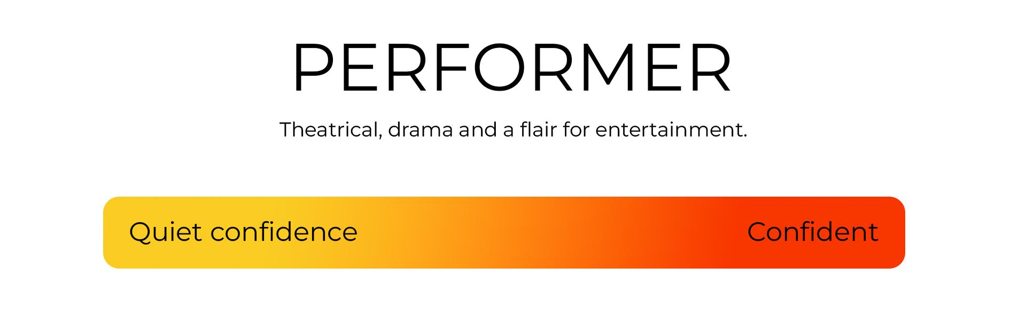
Engaging and Dynamic: Performer presenters are highly engaging, using dynamic expressions, gestures, and vocal variations to capture and maintain audience attention.
High Energy Levels: They often present with high energy, which involves being more animated and expressive to convey enthusiasm and keep the audience engaged.
Adaptability: Demonstrates the ability to adjust presentation style based on content, switching between modes (e.g., "Panto mode" for high energy and "Sneaky mode" for more intimate, serious moments).
Emphasis on Viewer Engagement: Focuses on techniques that directly engage viewers, such as smiling, which is scientifically proven to be contagious and helps build a connection with the audience.
Examples of performers
Alex Hormozi (confident)
Tom Scott (quiet confidence)
Matt Watson (confident)
Nico Leonard (confident)
MrWhoesTheBoss (confident)
Andrew Tate (off the chart confident)
Confident vs quiet confident presenters
Quiet Confidence Presenters:
Subdued and Subtle: Their confidence is conveyed through a calm, composed demeanor rather than high energy or dramatic gestures.
Minimalist Presentation Style: They rely more on the strength of their content and the sincerity of their delivery than on dynamic body language or vocal variation.
Engagement Through Content: The connection with the audience is built through thoughtful, well-articulated points rather than a charismatic performance.
Non-Polarizing: Tend to maintain a neutral stance that is less likely to provoke strong disagreements, aiming to be relatable to a wide audience.
Focus on Authenticity: Their presentation is deeply authentic, sharing insights and stories that resonate on a personal level without needing to amplify their persona for effect.
Confident Presenters:
Energetic and Bold: They display their confidence through a vibrant, engaging presentation style, often using expressive gestures and variations in tone to captivate the audience.
Performance-Oriented: More likely to employ theatrical elements in their presentation, such as storytelling, humor, and dramatization, to make their point.
Engagement Through Personality: Their connection with the audience is heavily influenced by their personal charisma and the energy they bring to the presentation.
Potentially Polarizing: Their strong opinions and distinct style might strongly resonate with some viewers while alienating others.
Constructed Persona: May adopt a heightened version of their personality when presenting, amplifying certain traits to enhance engagement and memorability.
🚨 TASK 1 - Presenting exercise
Set up a camera, dont worry about a proper set up or mic and record yourself doing the following
Trick 1 - Position 1 & 2
- Record yourself presenting a line using position 1 & position 2 hand movement
- Watch it back, try again until it looks and feel natural
Trick 2 - Count your words
- Use your hands to show numbers and act out your words like sign language
- Watch it back, try again until it looks and feel natural
Trick 3 - Negative hand gestures
- Communicate negative content with your hands
- Watch it back, try again until it looks and feel natural
Trick 4 - Bonk your words on the head
- Use your hands to put emphasis on words
🚨 TASK 2 - Panto Mode
Panto mode will make you look more confident on camera
- Take a line from a script and record yourself presenting it multiple times with different energy levels
- Present with 150% energy
- Present with 130% energy
- Present with 110% energy
- Present with 90% energy
- Present with 80% energy
Watch it back, you are likely to see an energy level that works for you on going (it's usually about 110-120%)
🚨 TASK 3 - Experiment with pauses
- Shoot the line from your script and experiment with putting pauses that feel natural
🚨 TASK 4 - Sneaky mode
Sneaky mode is something you can use for more serious moments in your scripts
- Shoot the line from your script but pretend there is someone next door you don't want to hear it
More presenting techniques
Avoid Pointing at Viewers:
- Pointing can be interpreted as aggressive or angry, unless that's the specific intention.
Use Open Hands:
- Presenting with open hands can make you appear more honest and open.
- This gesture is used by reputable presenters and even politicians to convey sincerity.
Hands Down for Authority:
- Keeping your hands down can signify authority and certainty.
- Effective for emphasizing important points but can be perceived as negative if overused.
Avoid Closed Fists:
- Closed fists may convey determination but generally have a negative connotation and should be used cautiously.
Avoid Hand-on-Chest Gesture:
- Placing hands on the chest can signal defensiveness and create a psychological barrier with the audience.
- Keeping the body open is recommended for a more endearing presence.
Presentation Positioning (Sitting vs. Standing):
- Sitting while presenting can drain energy and reduce the use of body language, making the presentation less engaging.
- Standing is suggested to enhance energy and engagement, mimicking the dynamic of TED talks.
- Experiment with both sitting and standing to find which approach best suits your style and makes your presentation more effective.
The ultimate presenting hack - Teleprompters

Advantages of Teleprompter Use
- Efficiency in Filming: Reduces the number of takes by minimizing errors and omissions, significantly cutting down filming time.
- Editing Ease: Streamlines the editing process, as content delivered via a teleprompter requires fewer cuts and corrections.
- Professional Quality: Ensures a polished, professional appearance by helping you stay on track without the need for extensive off-camera notes or memorization.

Setting Up Your Teleprompter
- Choose the Right App: Opt for a reliable teleprompter app, like Parrot iPhone/Parrot Google Play

Practical Teleprompter Tips
- Adjust Text Size and Speed: Customize the text size and scroll speed to match your reading and speaking pace for seamless delivery.
- Present in Segments: Don't try to present the entire script in one go. Present a few lines and stop, allowing for natural pauses and energy conservation.
- Use a Remote Control: If available, use a remote to easily pause, play, or adjust the speed of your script without disrupting your flow.
- Space out your script: When you write your script, use spaces between lines or paragraphs, it'l give you natural catch up points and places you can pause to break and keep the pace manageable and the text easier to present.

Overcoming looking weird
- Maintaining Naturalness: To avoid the robotic appearance often associated with teleprompter use, occasionally glance away from the camera as if in thought, and remember to blink naturally.
- Eye Movement: Minimize noticeable eye movement by keeping the text width aligned with the camera lens, especially when using larger screens like iPads.
- Emotional Delivery: Even with a script, infuse your presentation with genuine emotion and emphasis where needed to keep the audience engaged.

Teleprompters I recommend
Elgato
Padcaster

